Eyeconic - Glasses Shop Management System

Use-Case Specification: Add contact lens

Version 1.0

Revision History

|  |  |  |  |
| --- | --- | --- | --- |
| **Date** | **Version** | **Description** | **Author** |
| 07/11/2019 | 1.0 | Start creating use case | Đỗ Nguyễn Hoàng Ân |
|  |  |  |  |
|  |  |  |  |
|  |  |  |  |

Table of Contents

1. Add contact lens 4

1.1 Brief Description 4

2. Flow of Events 4

2.1 Basic Flow 4

2.2 Exception 5

2.2.1 Add contact lens 5

2.2.2 Fill in the contact lens information 5

3. Special Requirements 6

4. Preconditions 6

4.1 Admin must be logged in 6

5. Postconditions 6

6. Extension Points 6

Use-Case Specification: Add contact lens

# Add contact lens

## Brief Description

This use case defines the step of adding existing contact lens from the database.

contact lens are added by the administrator.

# Flow of Events

## Basic Flow

The system administration clicks the add button then fills in the information of the new contact lenses. The system displays the updated management parameter value and logs the change

Step 1: Click the add buttons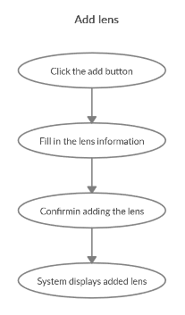

The modal view shows up

Step 2: Fill in the contact lens information, name, type, …

Step 3: Confirming adding the contact lens by clicking the “Save” button.

Step 4: Successful added contact lens is added to the screen.

## Exception

### Add contact lens

The add button cannot be clicked or isn’t appeared on the screen

### Fill in the contact lens information

Invalid information.

Must fill out all the information in the form.

2.2.3 Confirming adding the contact lens

The “Save” button is clicked but the new contact lens are not added to the database.

This new contact lens are existed in the database.

2.2.4 System displays added contact lens

The added contact lens is not display correctly

# Special Requirements

No Special Requirements

# Preconditions

## Admin must be logged in

User must already login as the administrator of the website

# Postconditions

contact lens are created and can be purchased by customers.

# Extension Points

Administrator check the website and the system to ensure that the contact lens are added to the database and display on the screen.